MACHINE LEARNING CLASSIFICATION
ASSIGNMENT STATEMENT

- PROBLEM IDENTIFICATION:
- First, we collect the data from the client, then from the collected data, we have to predict is the patient affect by Chronic Kidney Disease (CKD) as yes or no.
- Machine learning Supervised learning Classification

- Info about the dataset:
- 399 rows × 25 columns

- Pre-processing method:
- pc_normal(normal & abnormarl), pcc_present(present & not present), ba_present(present & not present), htn_yes(yes & no), dm_yes(yes & no), cad_yes(yes & no), appet_yes(yes & no), pe_yes(yes & no), ane_yes(yes & no), classification_yes(yes & no).

- Model :
- Random Forest

- Research values:
- SVM
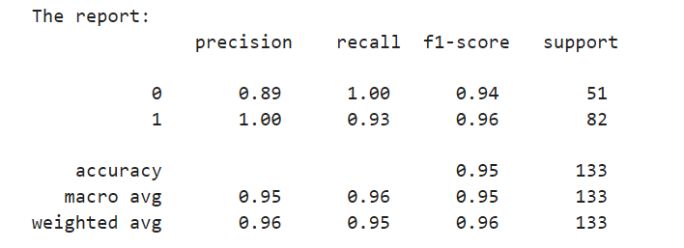

- RF
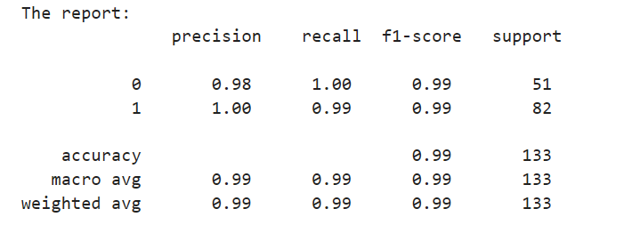
- Naïve bayes
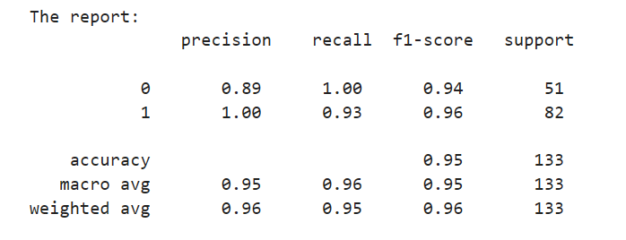
- Logistic regression
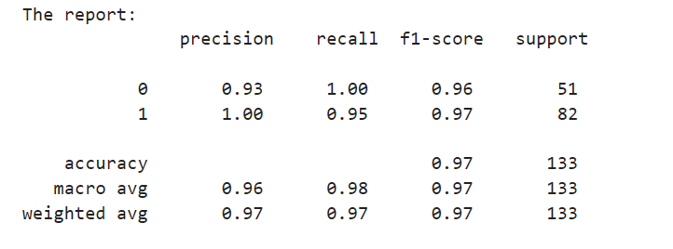
- KNN
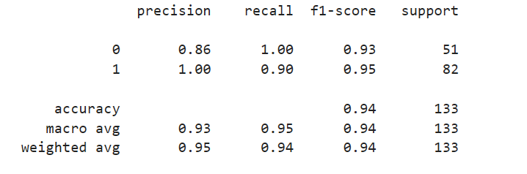

- DT
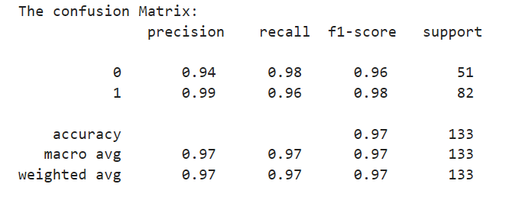

- FINAL MODEL NAME:
- Random Forest – This is a good model that’s confusion_matrix(accuracy) value is near by 1 with comparing other models.

